In Load balancer : if we need to run the

Basically we give health ck for port 80, sometimes we get the request to run the LB & web application on Port 80, but the health chk should be run in the 8080 port for this we need to use the { advanced health check settings 🡪 port🡪 override [8080] }

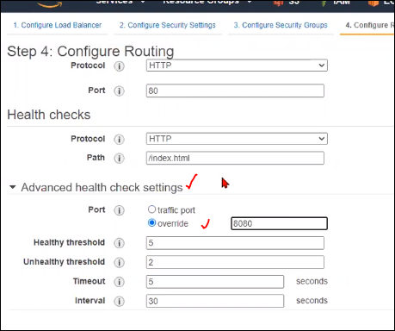

Only health check if we need to use other port instead of 80, then only we will use this.. [override].

We need to add that 8080 port in the listener.then only it will work.